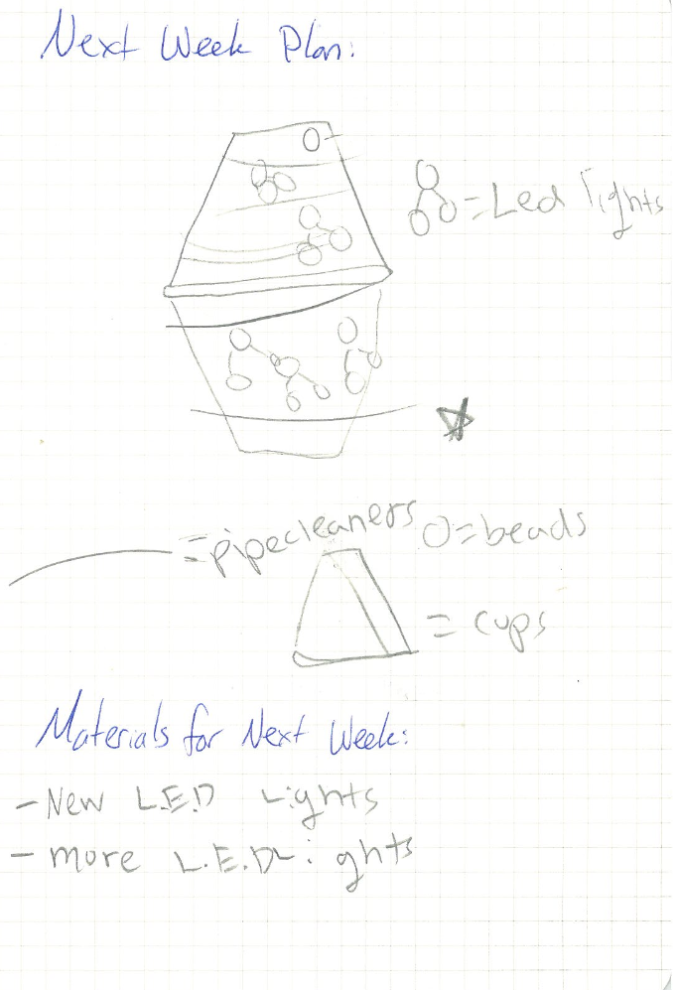
Grade 3; Group 1

Grade 3; Group 1

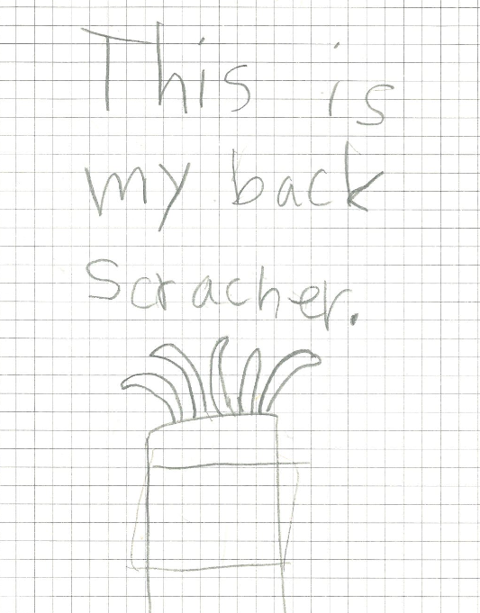
Grade 3; Group 2

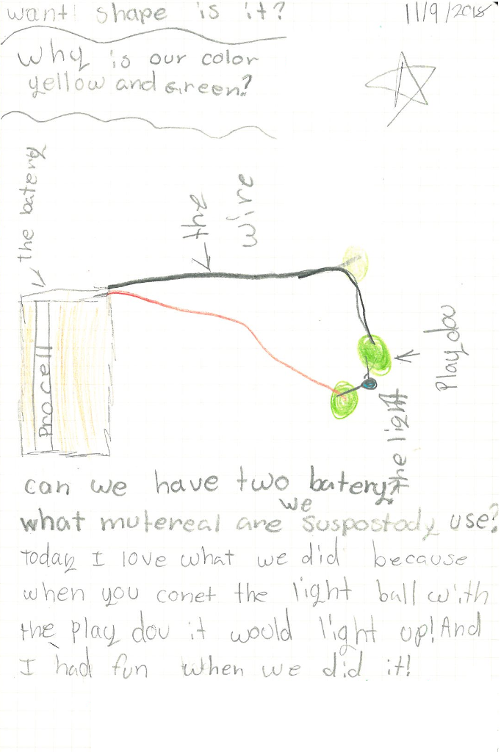
Grade 3; Group 2

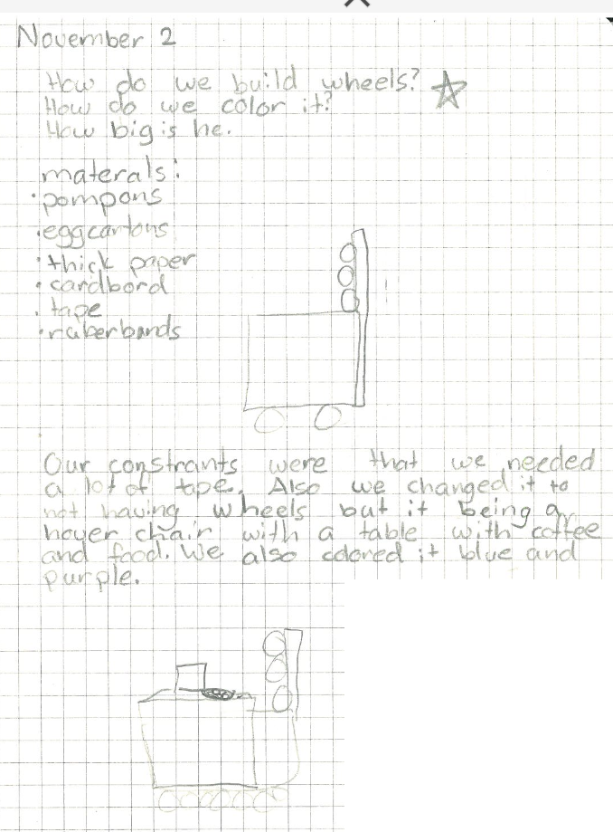
Grade 3; Group 3

Grade 4; Group 3

