Client Sheet
Name: Steve, Bear Extraordinaire

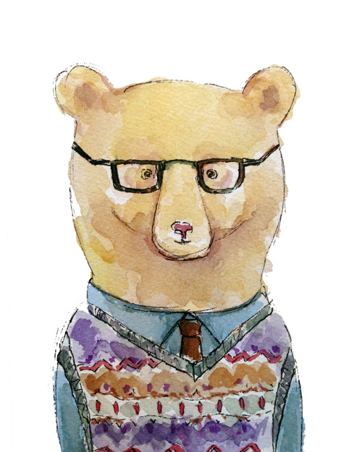

Info About Steve:
- A teacher at a university (like Tufts!)
  - Grades a lot of papers
- Bikes to class every day
- Drinks too many cups of coffee (but not tea)
- Complains about how much his back hurts
- Likes the colors blue and purple
- Wears glasses - can’t see very far away

