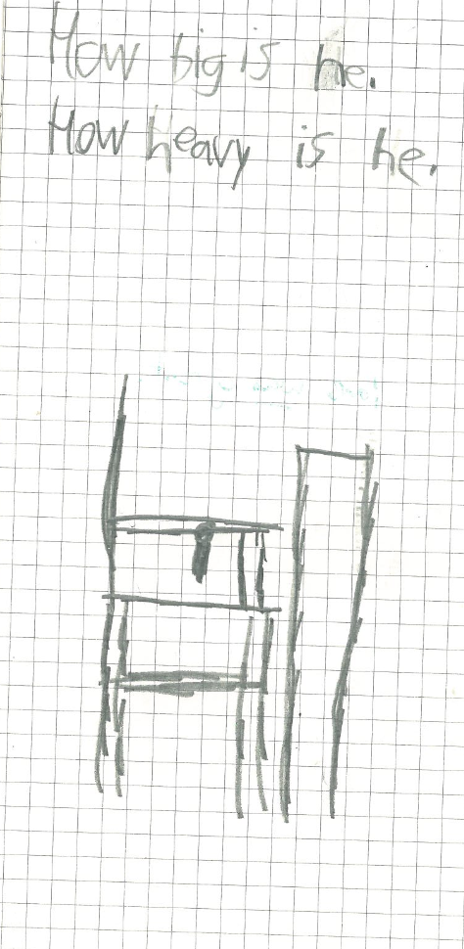
Grade: 3
Description:
Design process: starts with questions
Detailed drawing
Components not labeled for material or function
Looks like a chair, but purpose of design is unclear (comfy chair for Steve)

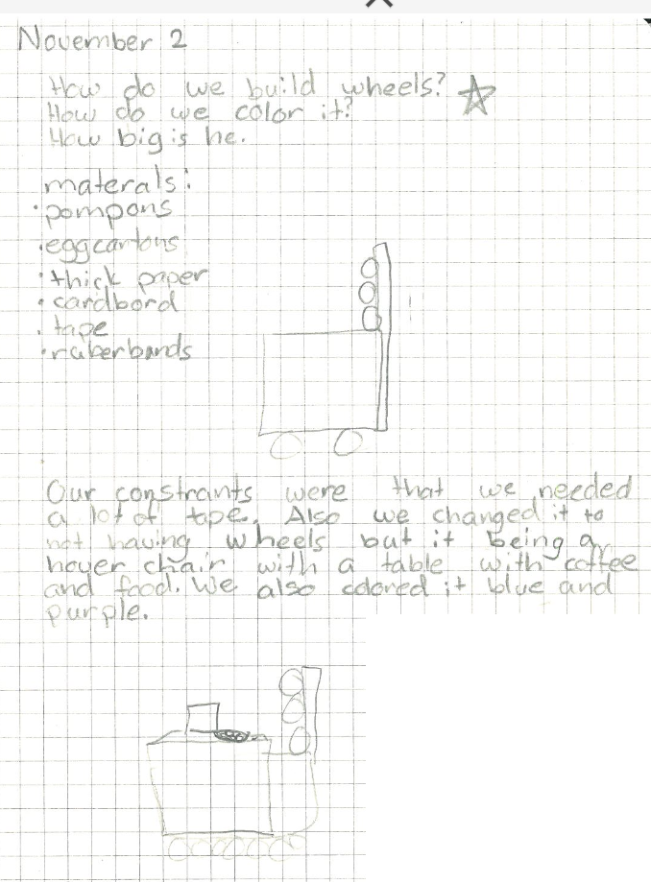
Grade: 3
Description:
Design process: starts with questions
Materials list
Evidence of iteration
Constraints!
Detailed drawing
Material and function of components is not clear
Hover chair? Questionably “buildable”
Purpose of some design elements is clear (table for coffee and food) but not all (back support in the seat of the chair)
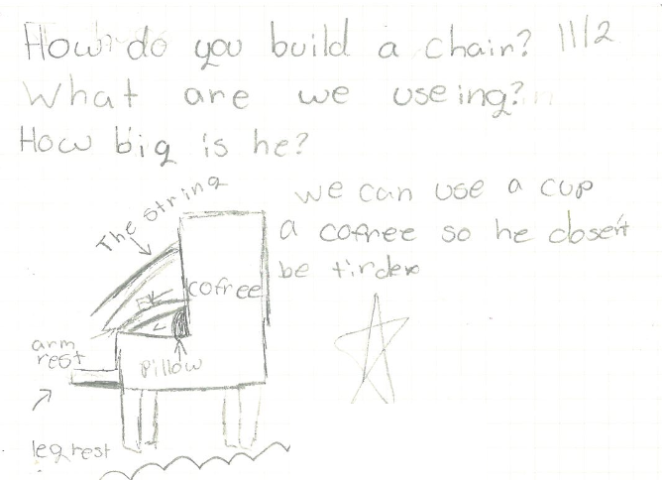
Grade: 3
Description:
Design process: starts with questions
Detailed drawing
Functional labels (arm rest, leg rest) and some material labeling (string)
More material labeling would increase clarity (what is the arm rest made of?)
Written justification: coffee so he [Steve] isn’t tired
Purpose of design clear (due to functional labels and written justification)

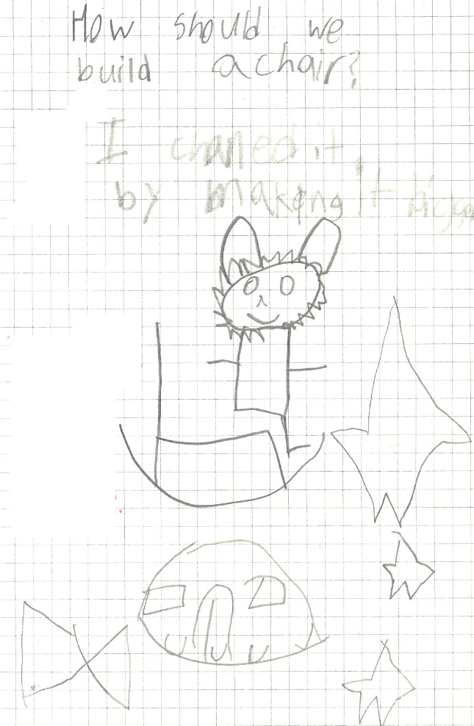
Grade: 3
Description:
Design process: starts with a question
Iteration: I changed it by making it bigger
Simple drawing
No material label or list
No functional labels
It’s clearly a chair, but purpose of design is unclear beyond that
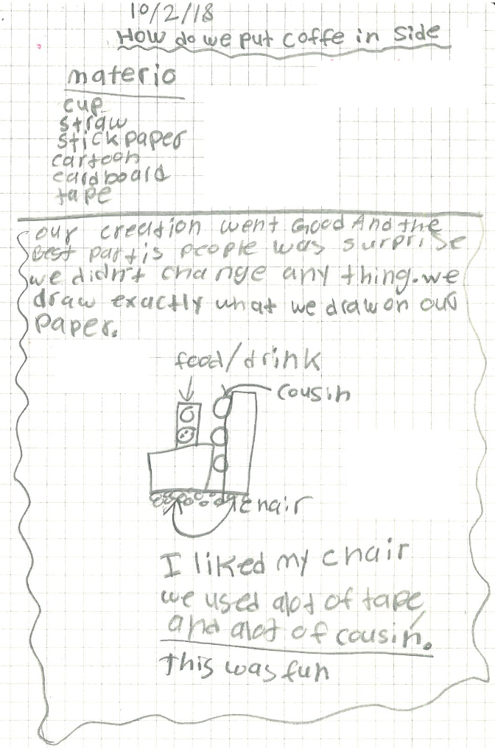
Grade: 3
Description:
Description:
Design process: starts with questions
Material list
Reflection: was good, didn’t change anything, a lot of tape, a lot of cushion, was fun
Moderately detailed drawing
Functional labels (cushion, food/drink)
Material labels would bridge between material list and functional labeling
Purpose of overall design is generally clear (definitely a chair, with cushions, accessible food/drink)

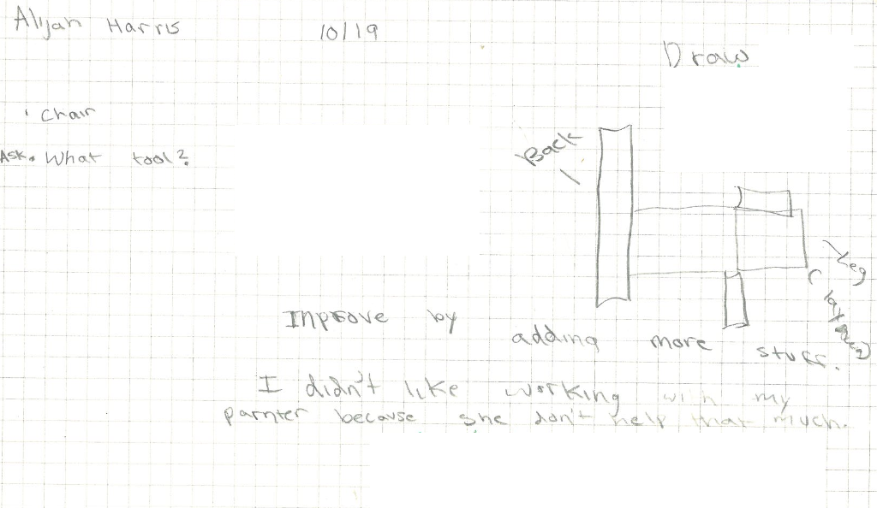
Grade: 4
Description:
Design process: start with questions, “Draw” step identified
Attempt at iteration: improve by “adding more stuff”
Reflection: didn’t like to work with partner
Simple drawing (side view!)
Functional labels (leg, back, lay down)
No material list or material label
Purpose of overall design is somewhat clear (chair + lay down) but could be clearer

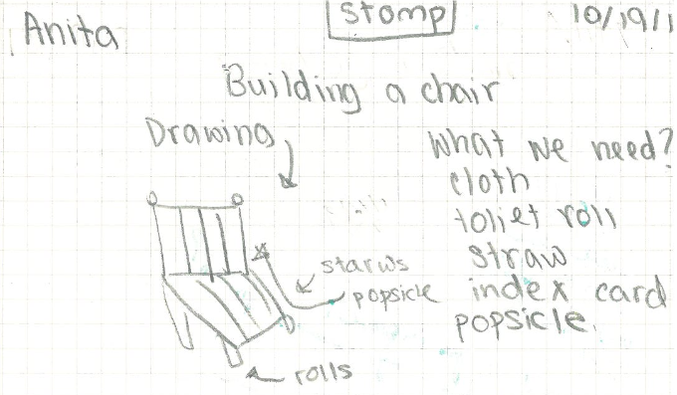
Grade: 4
Description:
Starts with a question
Material list
Purpose of design is somewhat clear (building a chair)
Moderately detailed drawing
Materials labeled

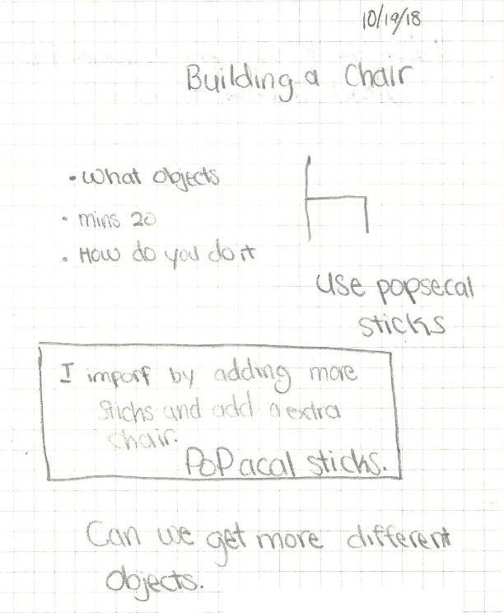
Grade: 4
Description:
Purpose of design somewhat clear (building a chair) but not specific (back support)
Very simple drawing
Design process: starts with a question, constraint (time)
Evidence of iteration: add more sticks
Reflection: wants other materials
Written description: use popsicle sticks
No material or functional lables
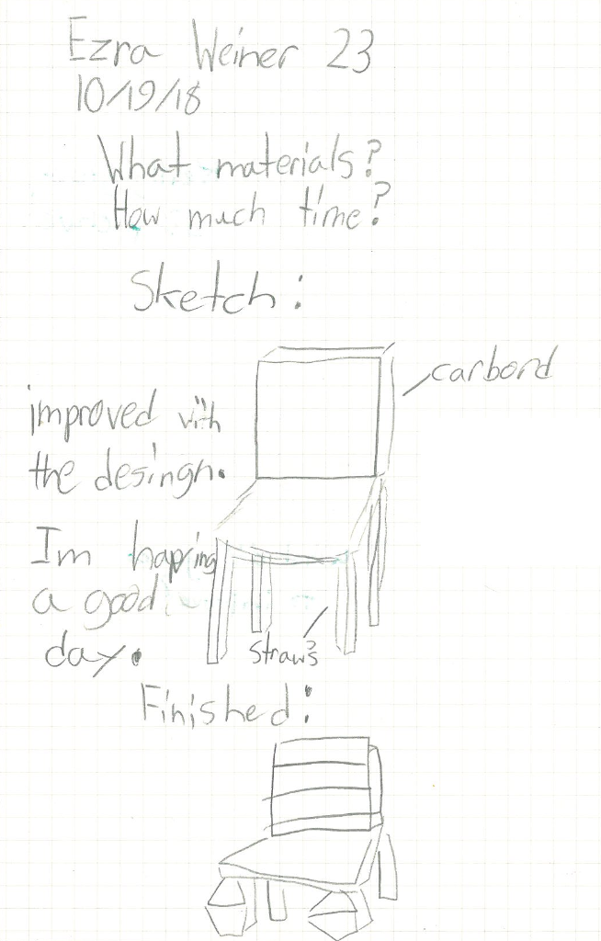
Grade: 4
Description:
Very skillful (3D) drawing, moderately detailed
Design process: starts with questions
Evidence of iteration: “improved” and a picture of the finished product as well as original plan
Reflection: good day
Some material labels: cardboard, straws
No functional labels
It is clearly a chair, but specific purpose of the design components is unclear (client needs)

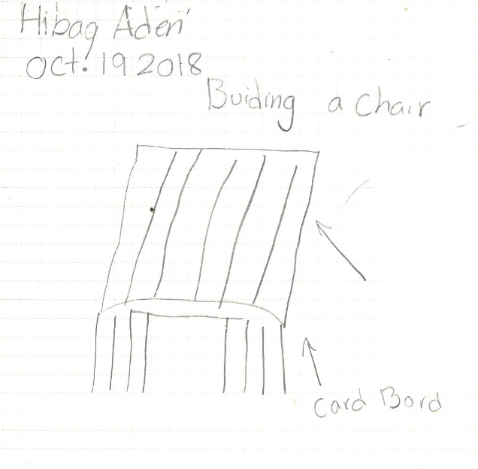
Grade: 4
Description:
Simple drawing
One material label
No function labels
Purpose of the design is somewhat clear (chair) but not specific

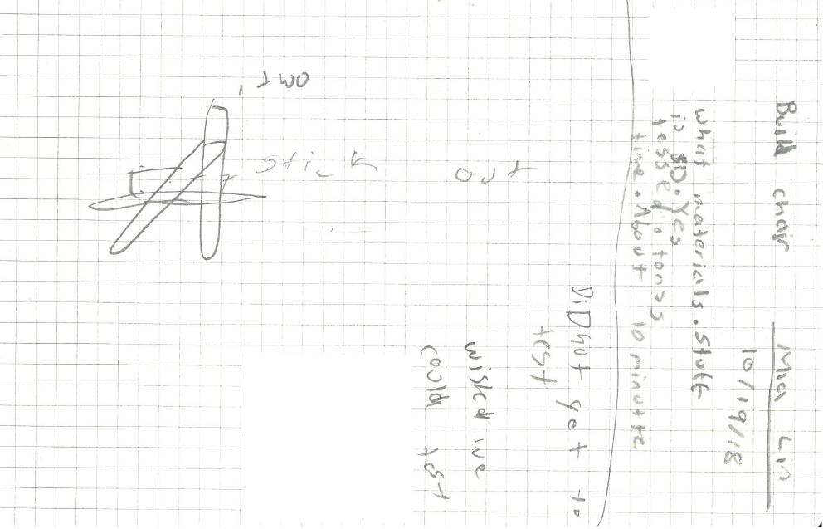
Grade: 4
Description:
Somewhat detailed drawing (shows arrangement of – presumably - popsicle sticks)
Design process: starts with questions, constraints (10 min)
Reflection: wished we could test
No material or functional labels
Purpose of design somewhat clear (build chair is written) but not specific

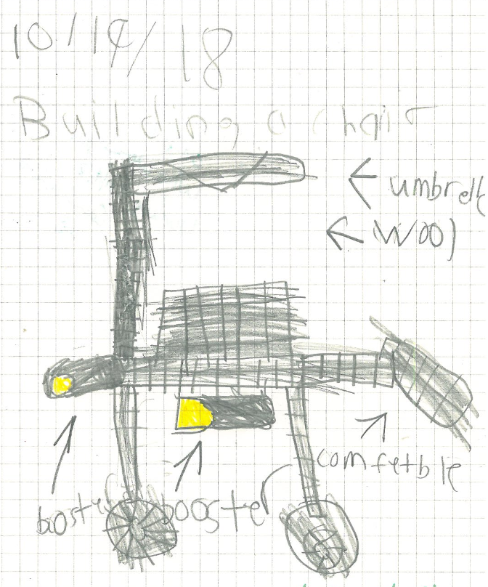
Grade: 4
Description:
Moderately detailed drawing
Some functional labels (but what is a booster?)
One material label - wool
Purpose of design generally clear (building a chair + comfortable)

